Name:

CODEBOT MISSION 5 LOG - Lesson 3

Pre-Mission Warm-Up
Identify the parts:  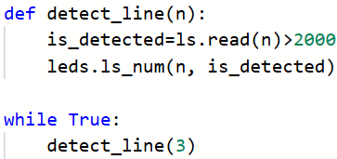
  Function definition
  Parameter
  Argument
  Function call
  Another argument
Mission 5 Lesson 3 – Fence Patrol
Mission 5 Objective 6
What does this code segment do?
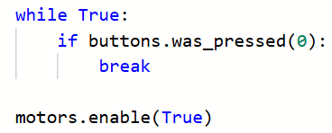
Mission 5 Objective 7 (Part 1)
Try the same problems in the chart. Each problem has a function with a return, and a function call.  What is the final value of answer after each function call?
  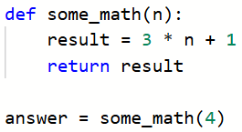 | 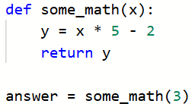
  answer = | answer =
  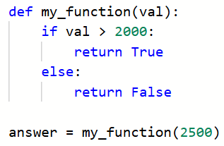 | 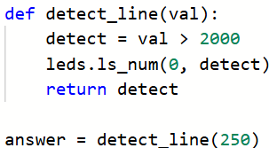
  answer = | answer =
What information will detect_line() return?
What information will scan_lines() return?
Mission 5 Objective 7 (Part 2)
What line of code assigns a variable the return value from scan_lines()?
What does this if statement do?
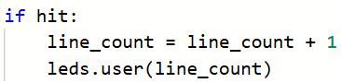
Run the code and count up to 255 line detections. This will turn on all user LEDs. Then detect one more line. The program ends with an error message. | What is the error message when the program ends?
Mission 5 Objective 8
What is a runtime error?
What does this code do?
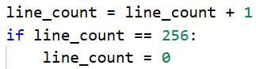
Post-Mission Reflection
How does a function send back a value to the function call?
Give an example of calling a function that has a return.

